**Wrapper classes** : wrapper classes provide a way to use **primitive data types** **(int, char, short, byte, etc.) as objects. OR** The**wrapper class in Java** provides the mechanism to convert primitive data types into object and object into primitive data types.

Since J2SE 5.0, **autoboxing** and **unboxing** feature convert primitives into objects and objects into primitives automatically. The automatic conversion of primitive into an object is known as autoboxing and vice-versa unboxing.

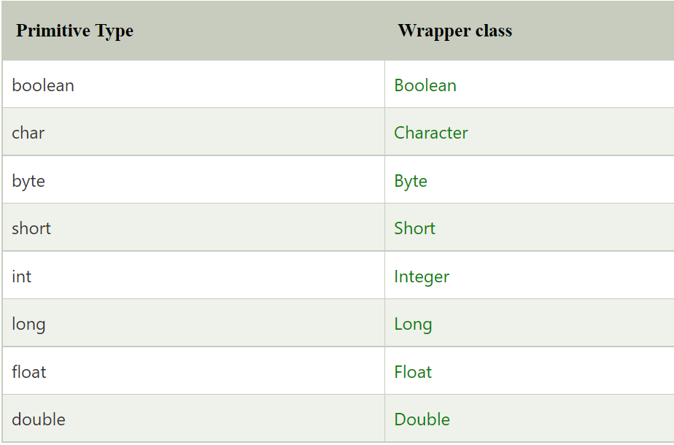

Example :

**public** **class** wrapper {

**public** **static** **void** main(String[] args) {

Integer myInt = 5;

Double myDouble = 5.99;

Character myChar = 'A';

System.***out***.println(myInt.intValue());

System.***out***.println(myDouble.doubleValue());

System.***out***.println(myChar.charValue());

}

}

These methods are used to get the value associated with the corresponding wrapper object: intValue(), byteValue(), shortValue(), longValue(), floatValue(), doubleValue(), charValue(), booleanValue()